

Foundations of Programming

Assignment No.: 07
PROBLEM STATEMENT: Write a C program to accept student details and display their result using an array of structures.

OBJECTIVE:

- To understand the concept of structures in C.
- To learn how to store multiple records using an array of structures.
- To accept and process student details such as name, roll number, and marks.
- To calculate total and percentage and display the result.

THEORY:
In C programming, a structure is a user-defined data type that allows grouping of variables of different data types under a single name. When multiple records such as student details need to be stored, an array of structures is used. This allows efficient storage and processing of student information like roll number, name, and marks in different subjects. The program can compute total marks and percentage and display the result for each student.

ALGORITHM :
Step 1: Start
Step 2: Declare structure student with:
- a. Roll no.
- b. Name
- c. Marks in 3 subjects
- d. Total marks
- e. Percentage
Step 3: Input number of students n.
Step 4: Declare array of structures of size n.
Step 5: For each student (i = 0 to n-1):
- a. Input roll no.
- b. Input name
- c. Input initial total = 0
- d. For each subject (j = 0 to 2):
  - i. Add marks to total
- e. Calculate percentage = total / 3
Step 6: Display "Student Result"
Step 7: For each student (i = 0 to n-1):
- a. Display roll no.
- b. Display name
- c. Display total marks
- d. Display percentage
Step 8: Stop

PLATFORM: Linux

INPUT: Student roll number, name, and marks in three subjects.

OUTPUT: Displays student details along with total marks and percentage.

SAMPLE INPUT:
Enter number of students: 2
Roll Number: 1
Name: Jesslyn
Marks in 3 subjects: 78 90 99

Roll Number :2
Name: Kathryn
Marks in 3 subjects: 89 91 92
SAMPLE OUTPUT:
Student Result:
Roll No: 1
Name: Jesslyn
Total Marks: 267

Percentage: 89.00%

Roll no:2
Name: Kathryn
Total Marks:272
Percentage:90.67%

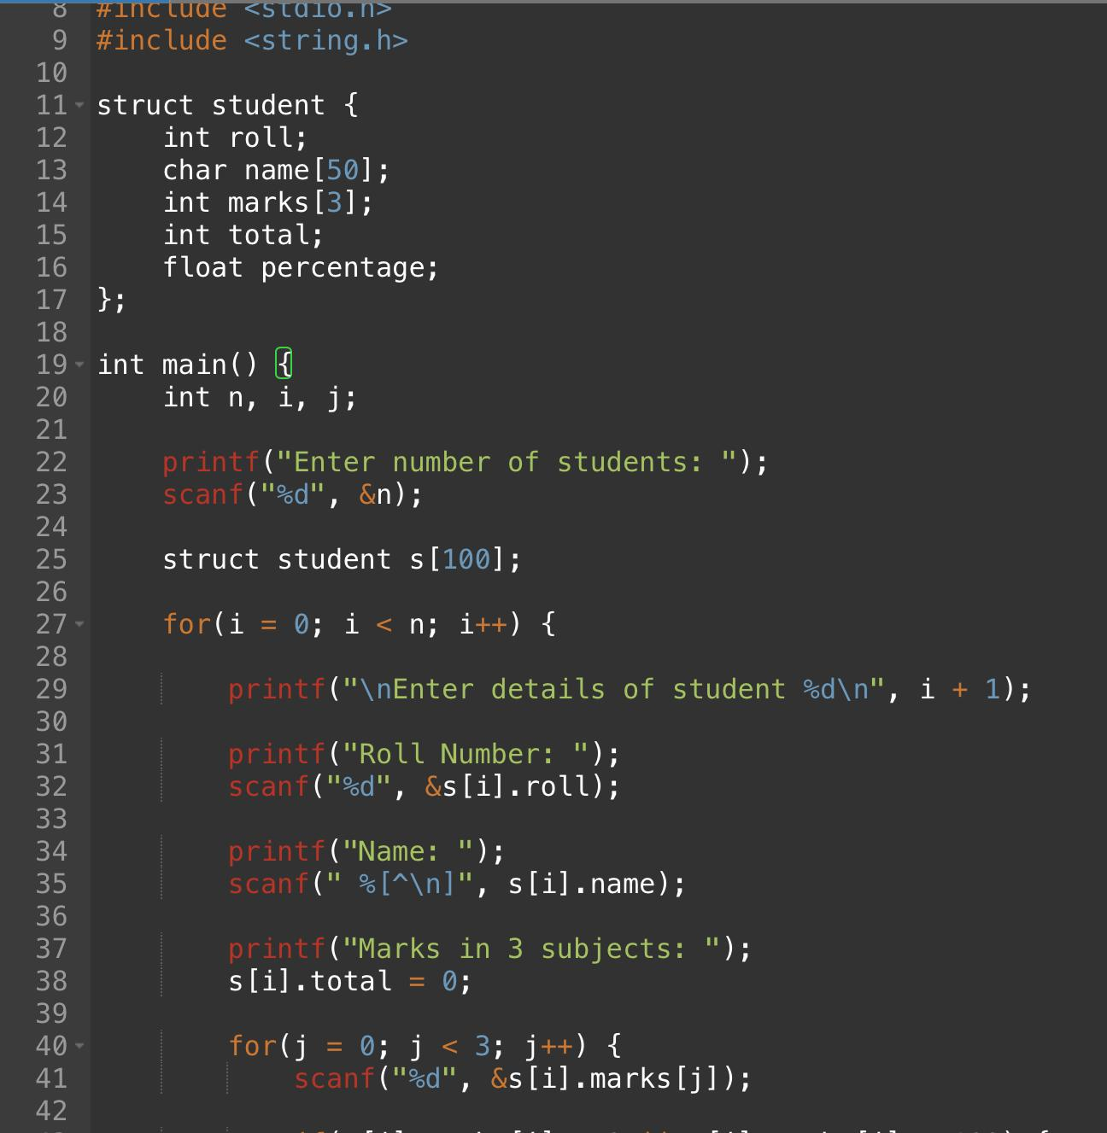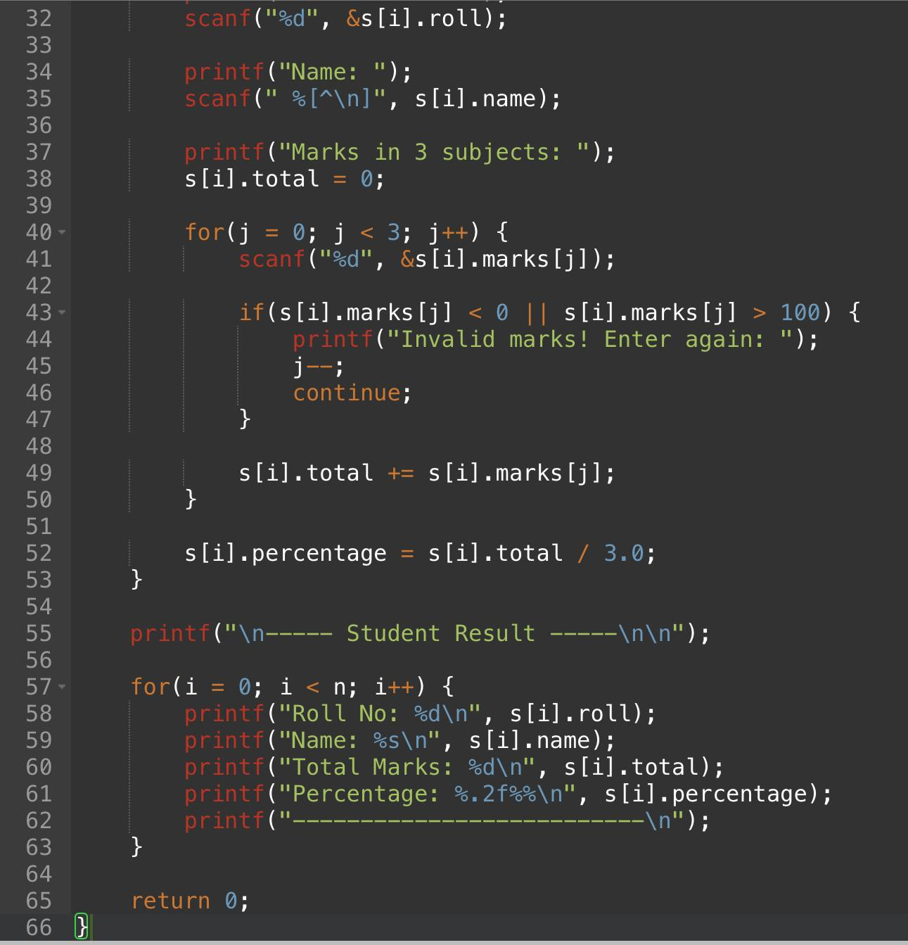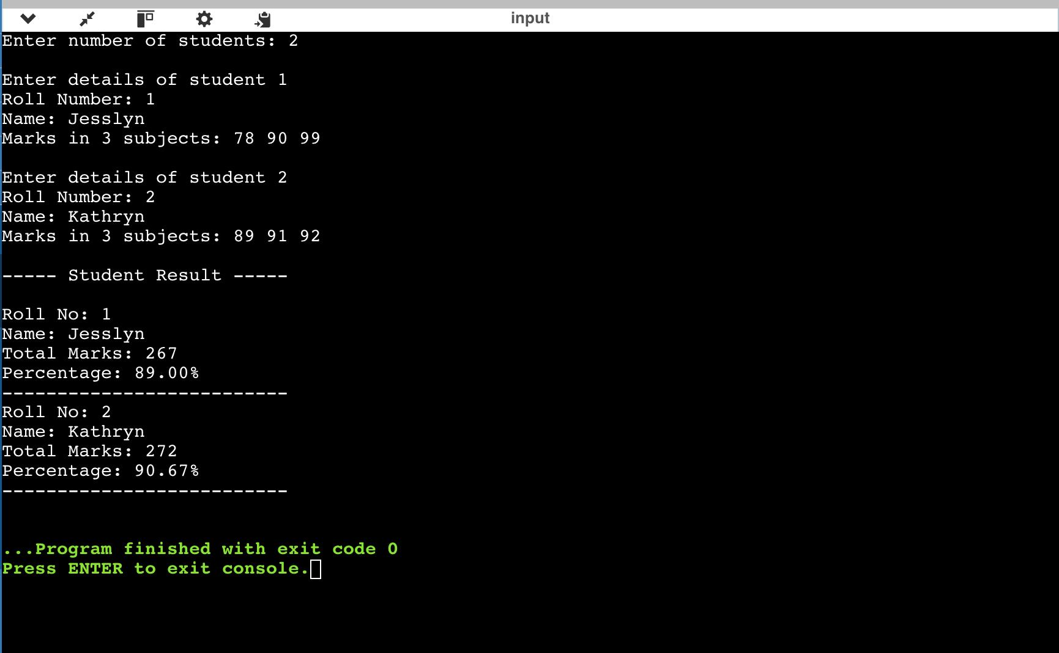
CONCLUSION: Thus, the C program successfully accepts student details using an array of structures and displays the calculated result including total marks and percentage.

FLOWCHART:
